Y-Axis Carriage
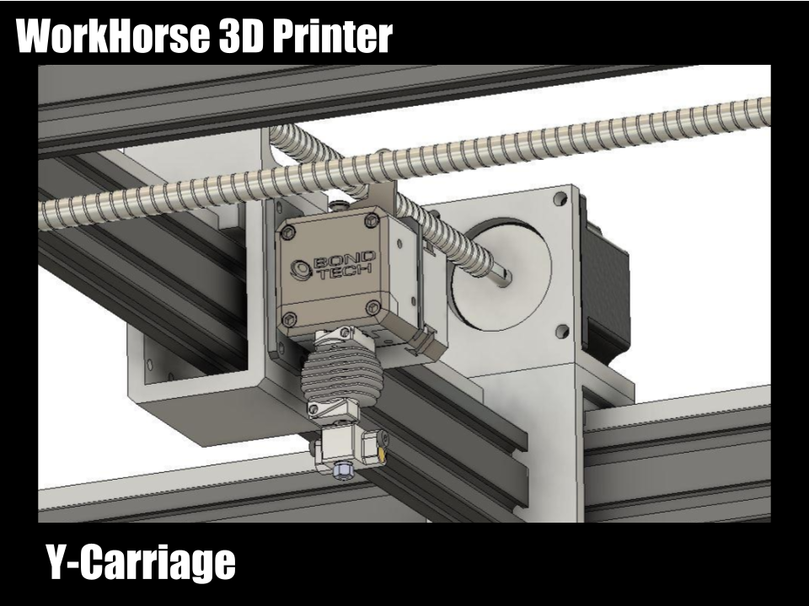

Y-Axis Carriage Design Updates
Reduced weight
Smaller footprint
Igus anti backlash lead screw nuts option
Dual Extruder
Bondtech Direct Drive

I'm considering making the X and Y-axis Carriage designs from a solid rectangular bar instead of 2" x 4" aluminum tubing. There will be an increase in wasted and machine time but the overall weight and footprint will decrease. The more compact design will allow faster printing speeds due to reduced deflection within the system.

New Carriage Design
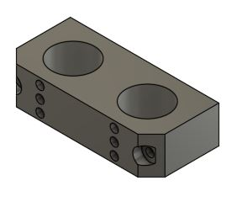
Y-carriage mounting holes now fit SolidCore hotend mounts

Related Content
WorkHorse BOM
Igus Lead Screw
Linear Rails
WorkHorse Frame
WorkHorse Motors
WorkHorse Printer: Users Guide
Duet Wifi Setup
Duet 2 vs Duet 3
WorkHorse 3D Printer
Recommended Print Settings
3D Distributed

Firmware Files
config.g
Homeall.g
homex.g
Homey.g
Homez.g

Duet 3 Mainboard Setup
Duet3D YAT Commands
Reverse Motor Direction

Duet Wifi
Duet Wifi Setup

Y-Axis Carriage Design Updates 1
New Carriage Design 2
Related Content 2

